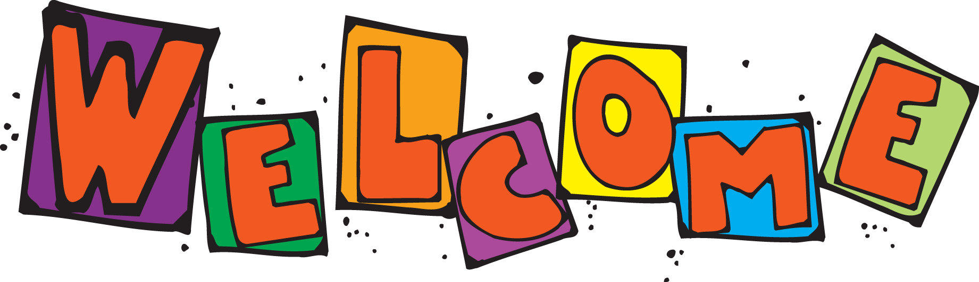

from Your School Counseling Team
We believe in working as a TEAM!
The school rules are be safe, respectful & responsible
Each building has a full-time counselor
All students will receive the same counseling curriculum
Methacton counselors support students & families

Meet the Team
Arrowhead: Jamie Friedman has been Arrowhead’s school counselor since 2002
Eagleville: Lori Shaw joins Eagleville after six years at Audubon and eight years at Methacton High School
Woodland: Linda Ehmer has been Woodland’s school counselor for the past 10 years.
Worcester: Shannon Broadhead has been at Worcester since it re-opened in 1999.
District: Judi Schmitz, formerly Eagleville’s school counselor, has transitioned to a new position as the K- 12 career counselor.
Save the Dates
Families from all elementary schools are welcome to attend these workshops:
Workout Your Worries: Tuesday, September 19, 2017 at Arrowhead Elementary
Homework Without Headaches: Wednesday, October 4, 2017 at Woodland Elementary
More information and registration information will follow.

